Application Engineering and Development

Assignment III-University Model

| **Name** | **Email ID** | **NU-ID** |
| --- | --- | --- |
| Pratik Talreja | talreja.p@northeastern.edu | 002108415 |
| Harshit Parikh | parikh.ha@northeastern.edu | 001044838 |
| Nirmiti Patil | patil.nir@northeastern.edu | 002103927 |

**Background:**

Our existing educational system focuses on delivering education to students on time without taking into account how kids acquire knowledge through the methods used to teach. This becomes a problem when individuals finish their education but still feel as though they don't understand the subjects or courses they took. When students enter the real world and are still unsure of what they are good at, this becomes a big issue.

**Purpose:**

The goal of this project is to create a system that considers how teachers, students, and courses perform over time and ranks each distinct entity while keeping the student's career and professional advancement in mind. We can determine which aspects of our educational system require improvement and make appropriate judgments with this type of feedback.

**Approach:**

We'll create a dashboard that will compile all the data gathered over the years and display reports comparing the success of students, professors, and courses. Administrators and students at the university can use the dashboard. Following the data collection, we will use various metrics to determine the performance of each entity. The following are some of the performance measurements that have been used:

1. Department Performance
2. Faculty Performance
3. Student Performance
4. Student Professional Growth.
5. Course Rating
6. Overall University Performance.

**WorkFlow:**

We will collect data from students in the form of feedback and how their career develops over time in order to obtain the data needed to track their performances. The following is our solution for gathering data for various metrics:

1. **Department Performance:**

To determine how well a department is performing, we will gather data from students and professors in that department.

Students will give feedback/ratings for their professors under which they attended the lectures based on how well the lectures and courses were.

1. Professor Rating = (Sum of all the ratings received) / (Number of Students who gave the rating)
2. Average Grade = (Sum of grades received by all students) / (Number of Students who gave the rating)
3. Course Rating

**Department Performance = ((A+B+C) /3) * 100 …..%**

**2. Faculty Performance:**

Professor Rating = (Sum of all the ratings received) / (Number of Students

who gave the rating)

**3. Student Performance:**

There are two metrics for students, one is the grade in that particular course and the other metric is the student’s total GPA.

Subject_Grade = Course_Grade

Student_GPA = GPA formula

**4. Student Professional Growth:**

A student’s professional growth depends on the type of role which the student gets after getting a job, years of experience, promotion and/or increase in responsibilities over the years.

**Years Of Experience:** In general, the amount of years someone has experienced is directly proportional to their knowledge in that sector.

Experience in a number of years = number of points.

**Promotion:** Another aspect we are taking into consideration is promotion; when someone is promoted while on the job, their responsibilities and expectations from the employer increase, which in turn makes the student perform well.

Promotion = (number of promotions * 2) / Years of Experience

Student Professional Growth = Years of Experience+Promotion

**5. Course Rating:**

This metric is challenging to calculate because it considers Student Professional Growth as well as the average grade achieved by all students who took the course.

Course Ratings = (SPG + Average Grade) / 2

**6. Overall University Growth:**

University’s performance depends on all the above factors combined. It means that it does not depend on a single entity but the contribution of all the entities working together, which we believe results in a good university rating.

OUG = ((CR + SPG + SP + FP + DP) / 5)

**Dashboard:**

1. **Home Screen**

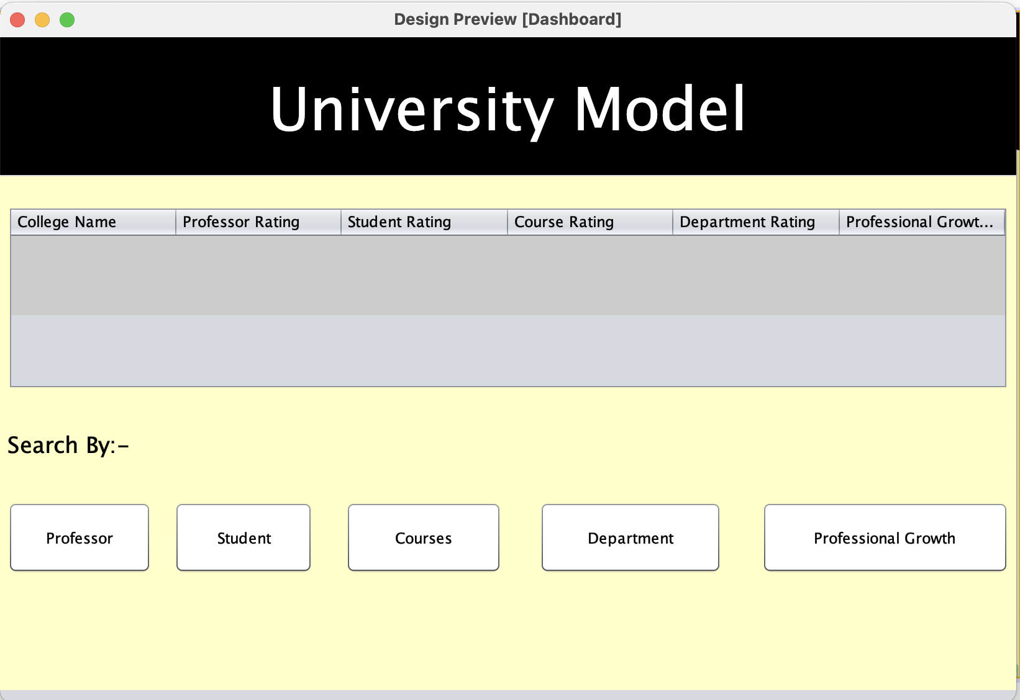

1. **Professor Screen**

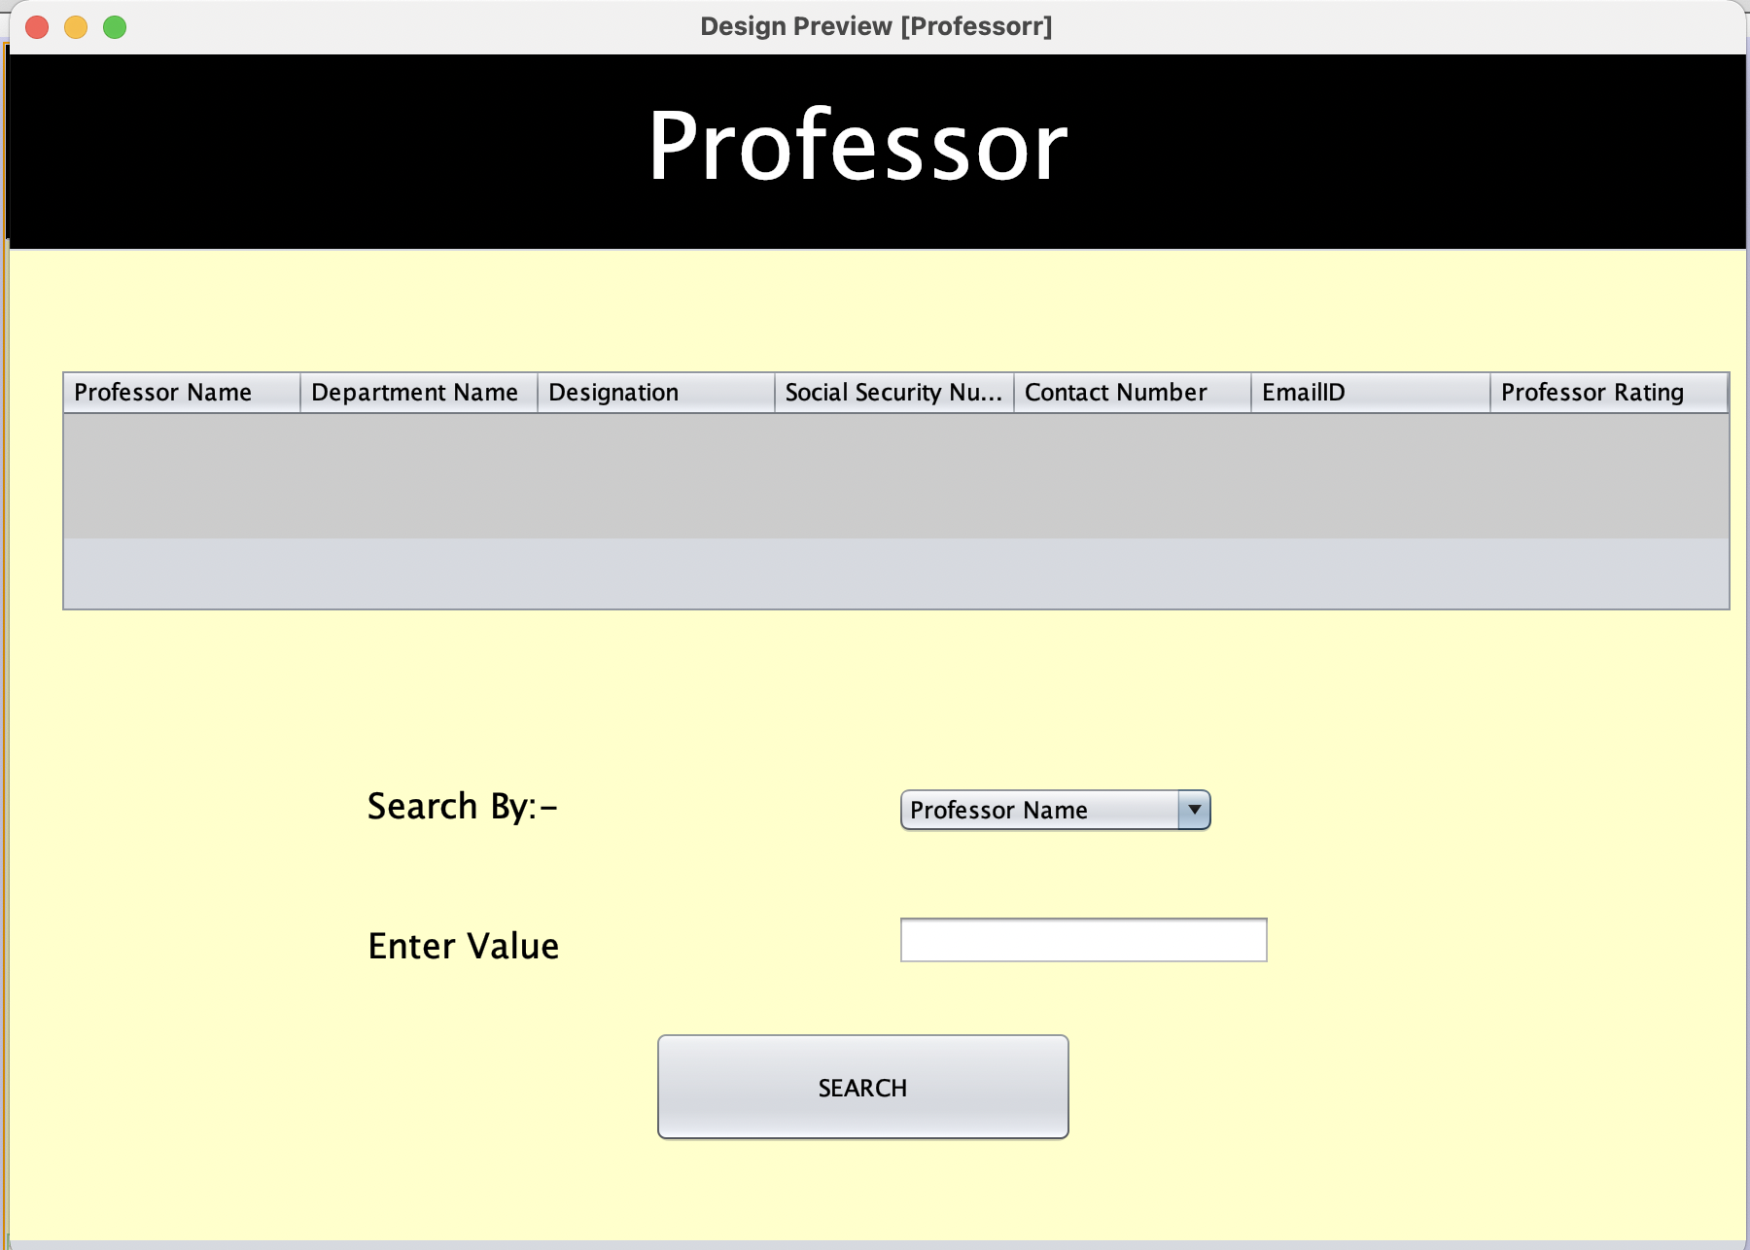

1. **Student Screen**

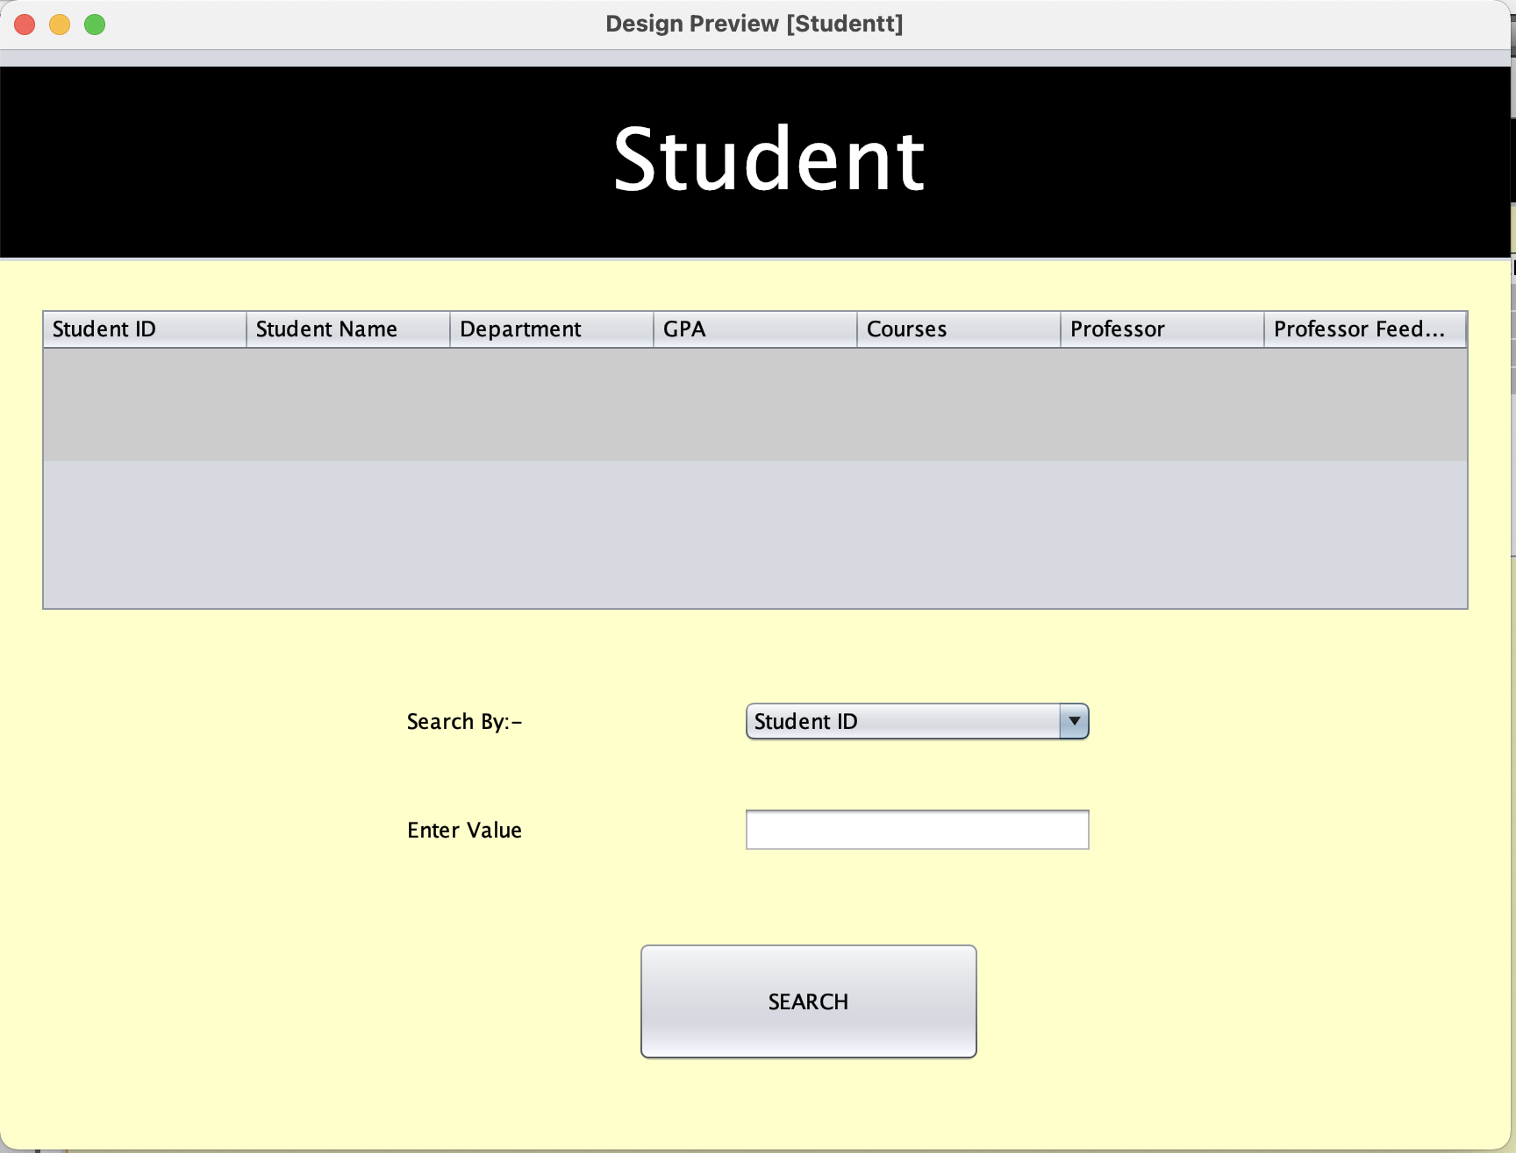

1. **Course Screen**

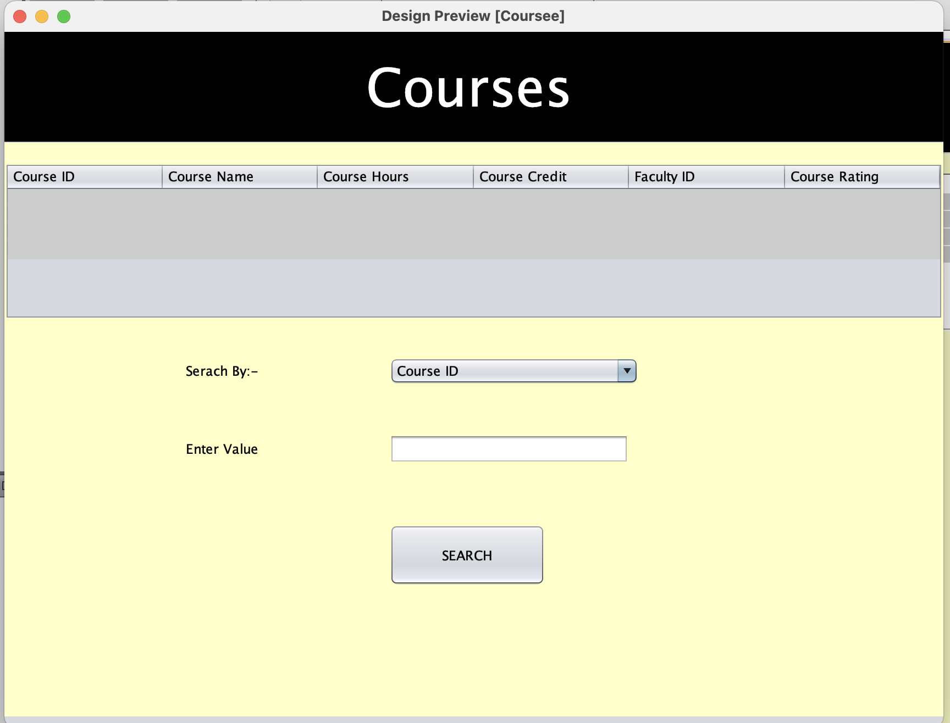

1. **Department Screen**

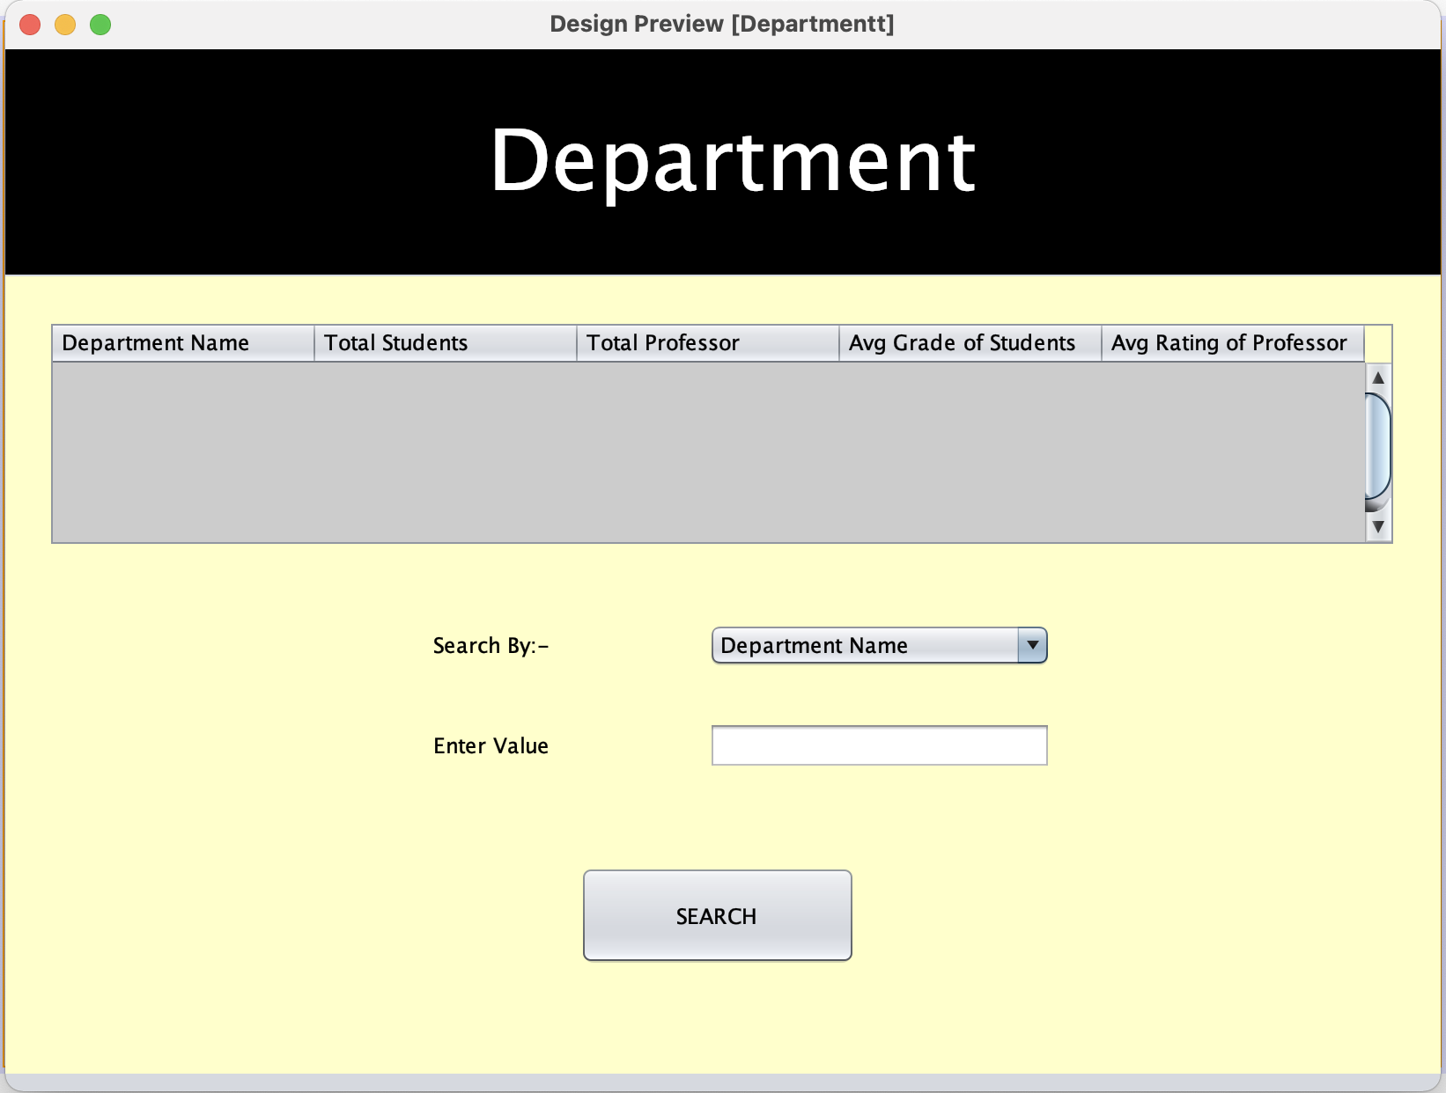

1. **Professional Growth**



**Conclusion:**

Here, we build a system where, if an entity is not performing well, it can be improved by taking proper measures and this, in turn, will increase the overall growth of the industry as everything is interconnected and interdependent on each other.